**Connecting to Redshift from AWS Glue**

Step1:

Go to IAM create IAM role for glue

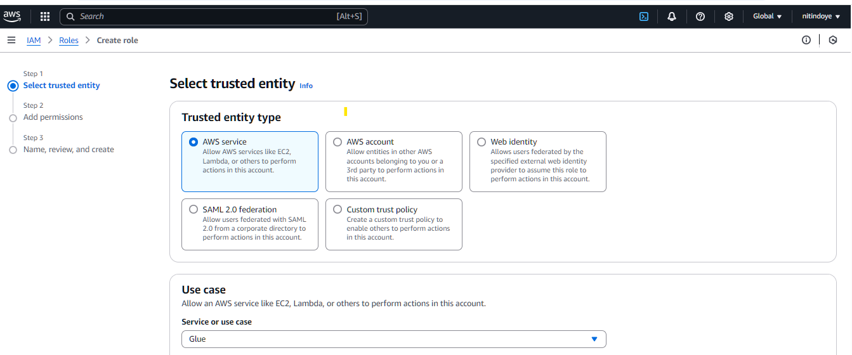

Then attach required permission to it

1. AmazonRedshiftFullAccess

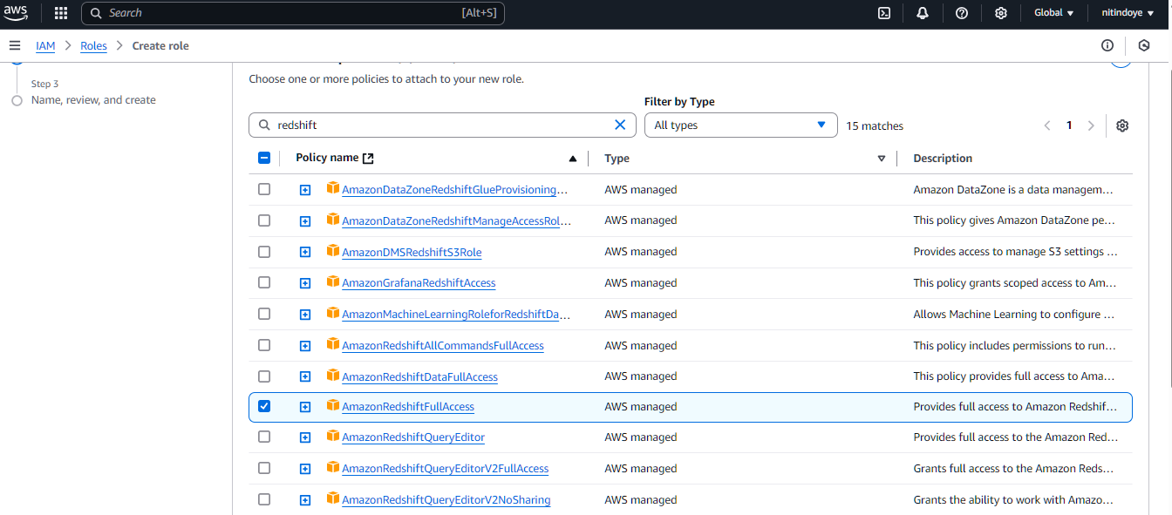

1. S3 Full Access

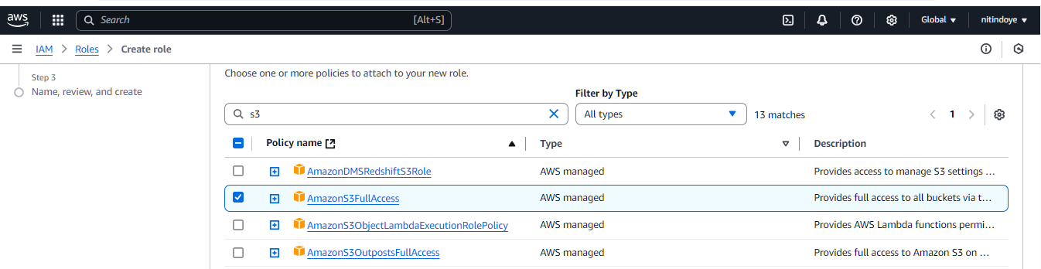

1. AWS Glue Console Full Access
2. AWS Glue Service Role

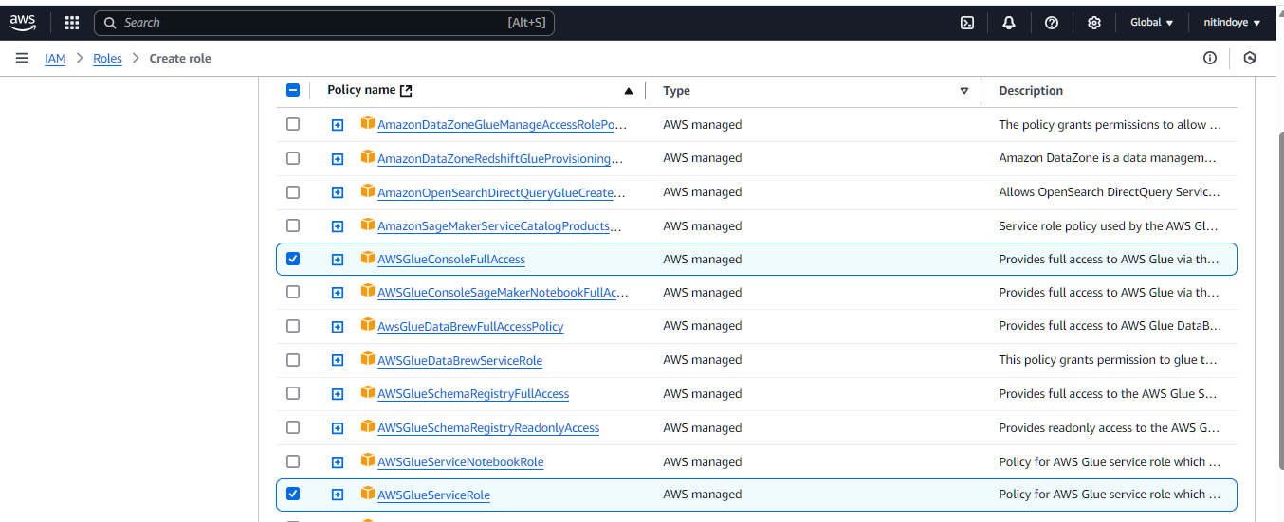

1. Secret Manager Read write Access

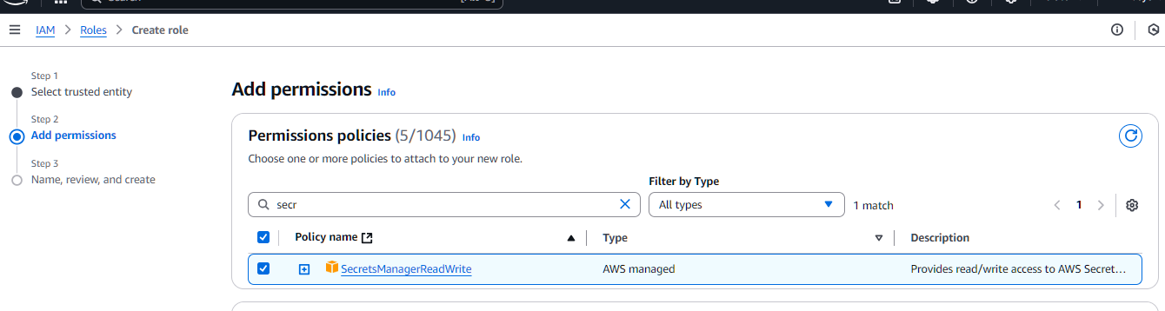

6.Key Management Service Power User

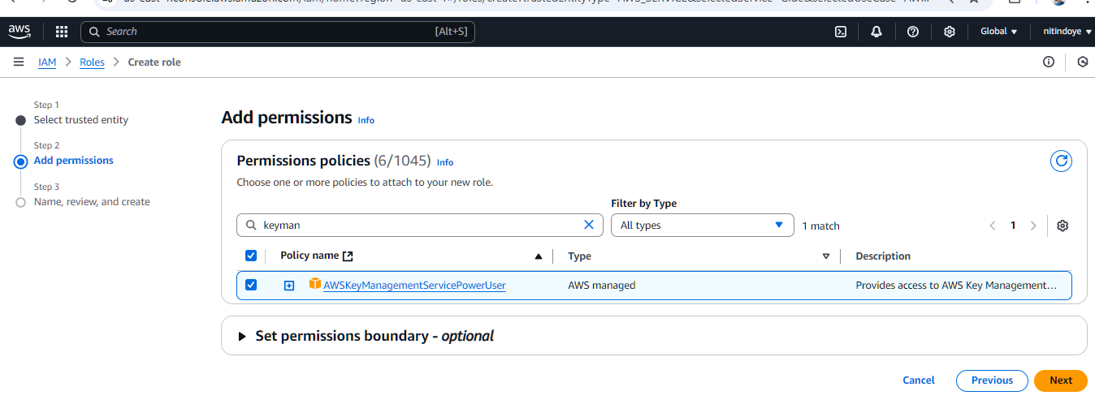Then click on next

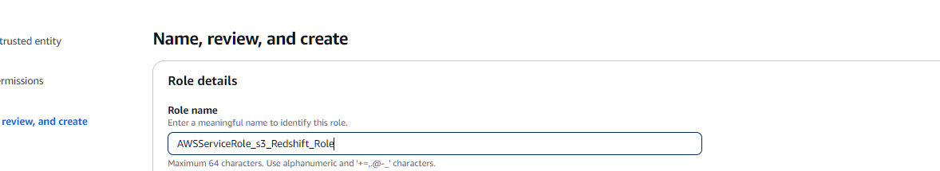

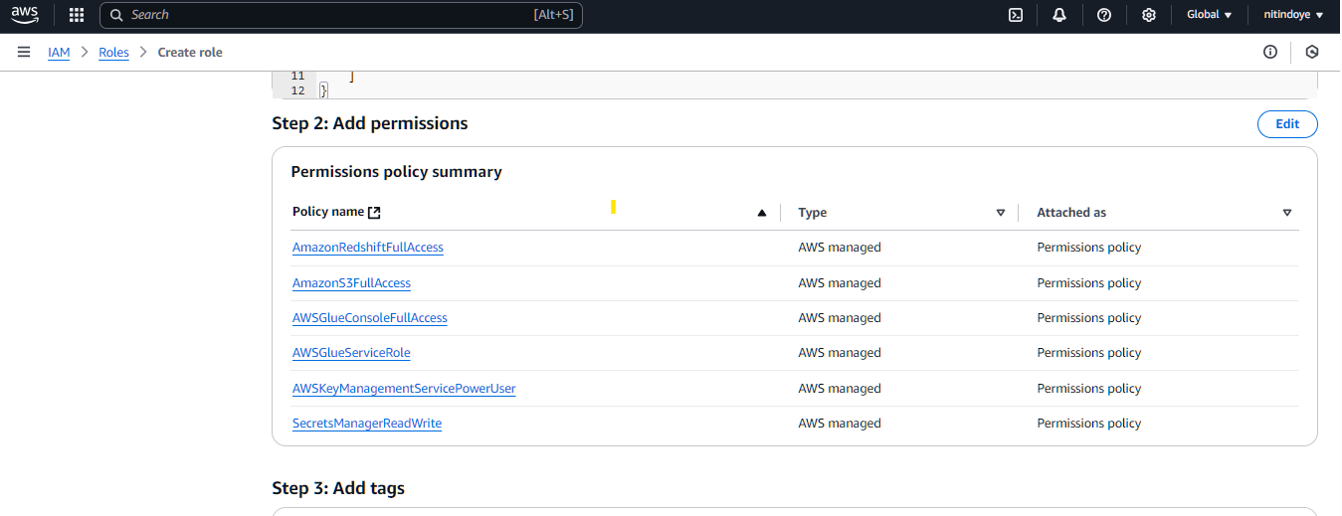

Click on create role

Step2:

Go to your serverless redshift dashboard

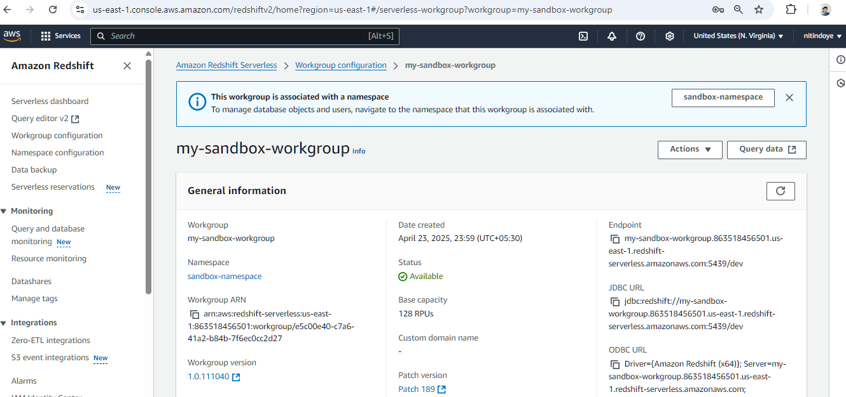

Go to workgroup

Click on VPC

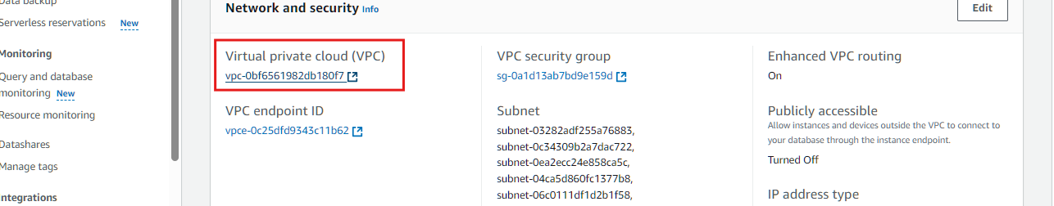

Go to endpoints

Create enpoints

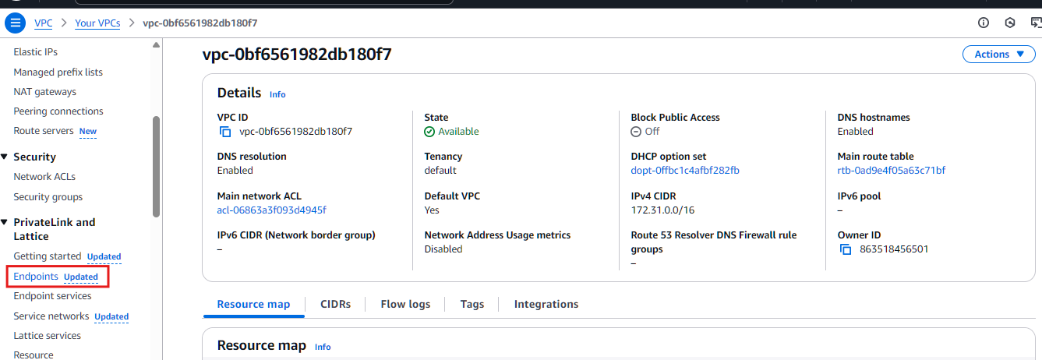

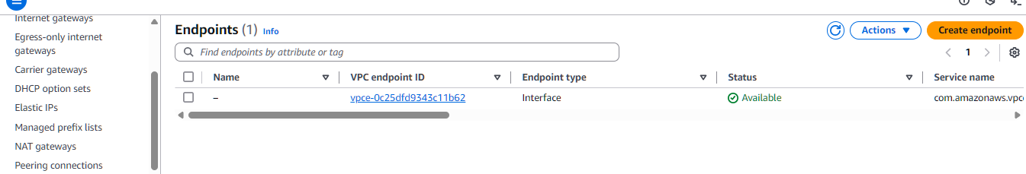

1. Create s3 endpoint

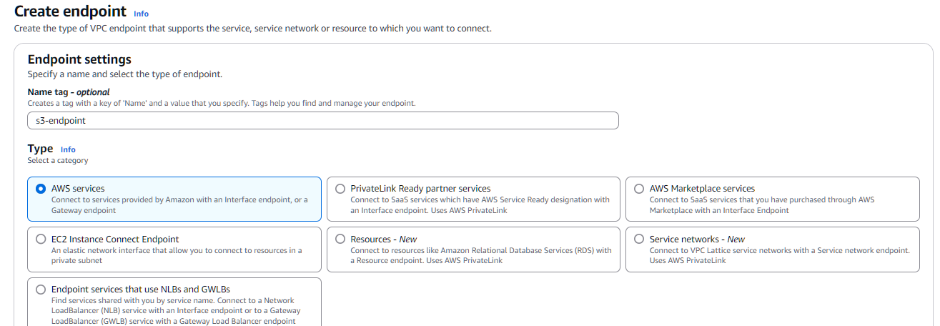

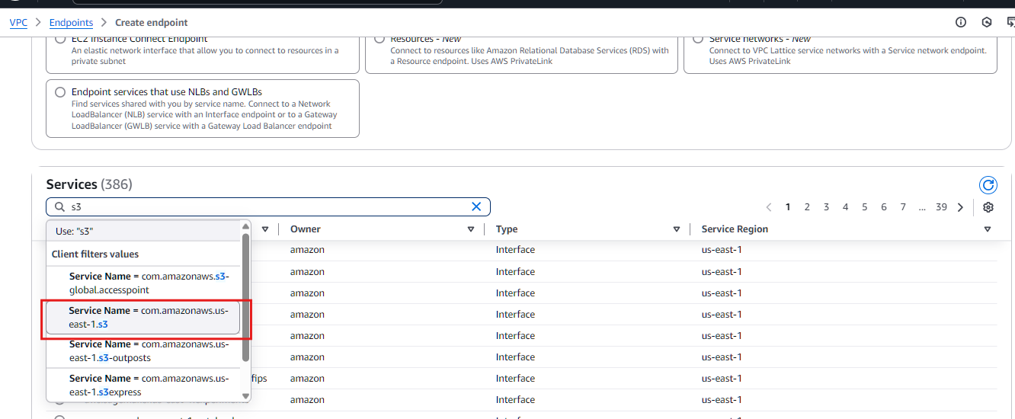

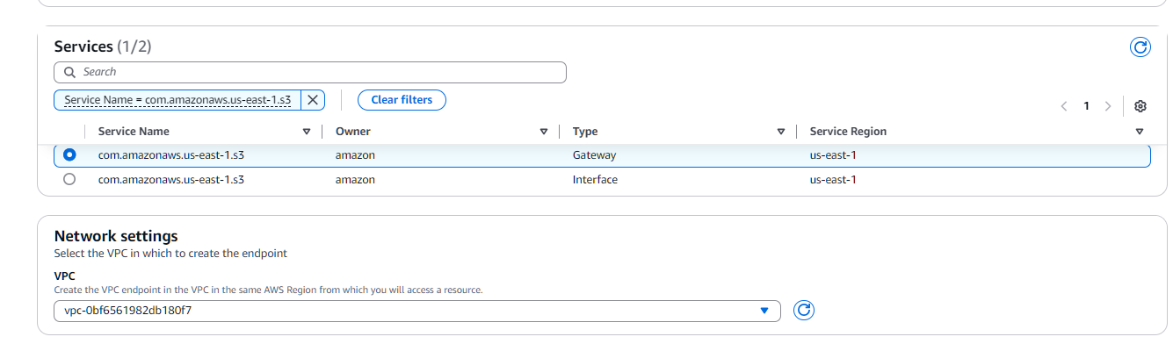

Choose Gateway type

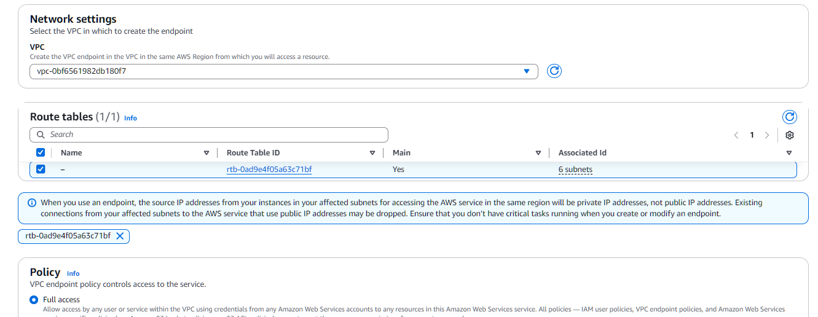

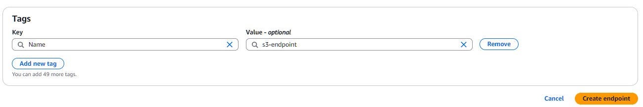

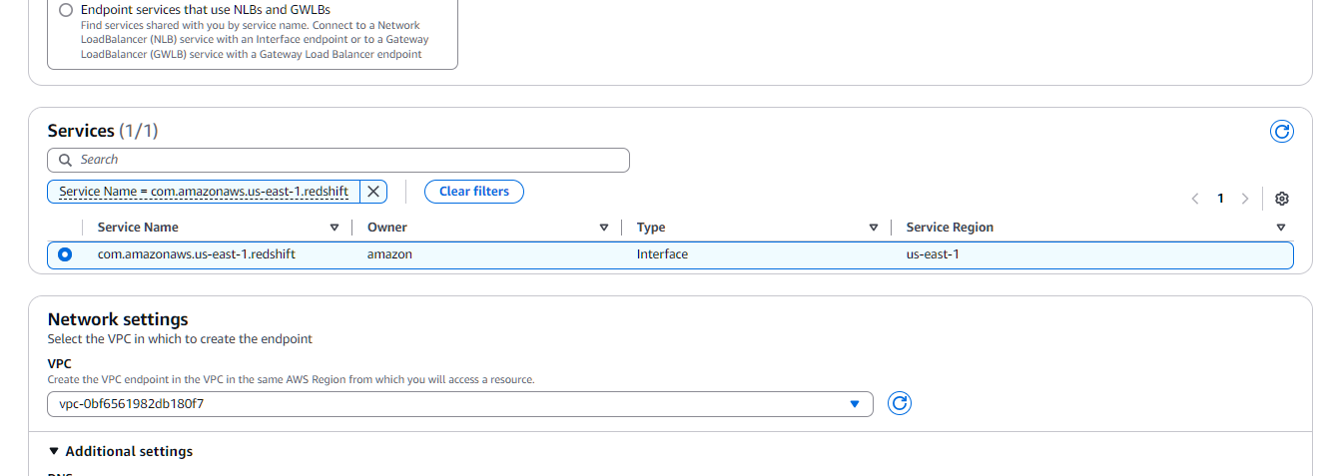

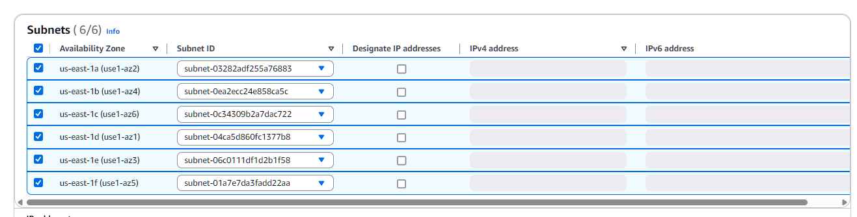

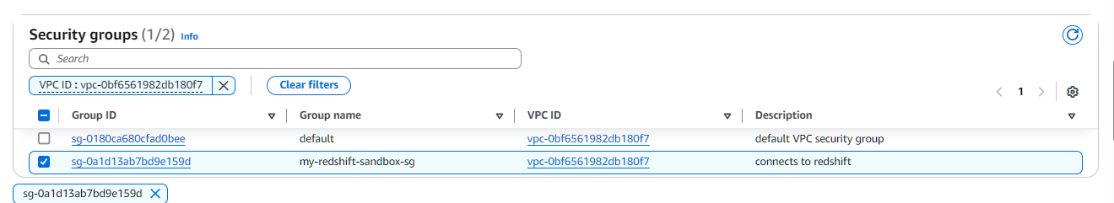

Secret manager endpoints:

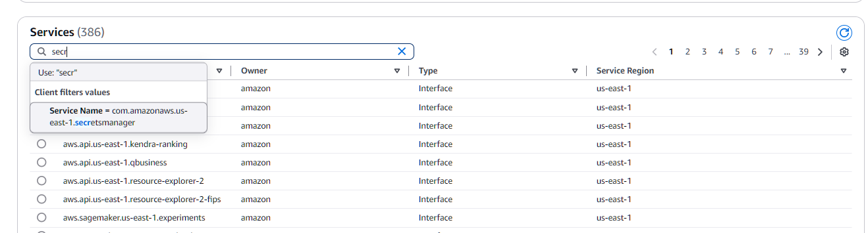

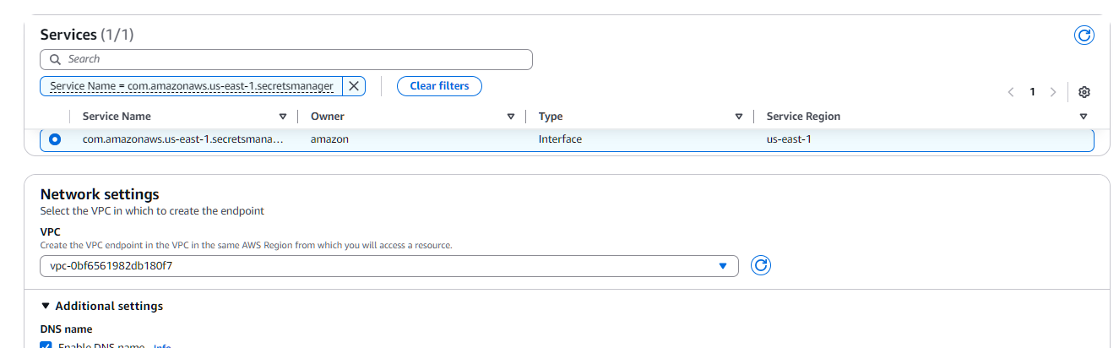

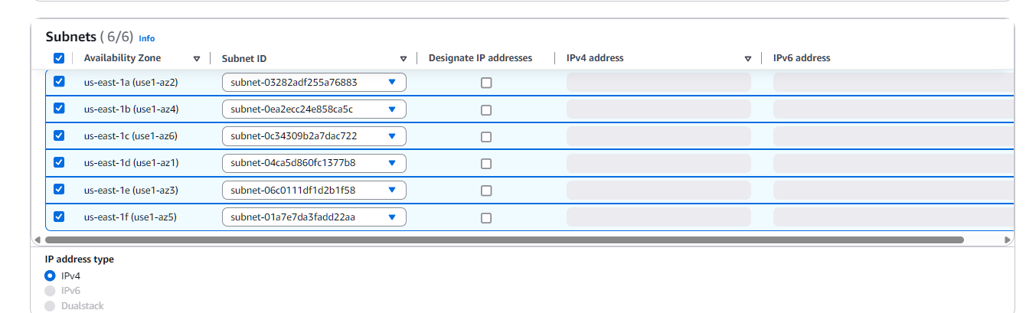

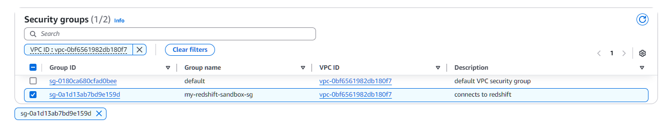

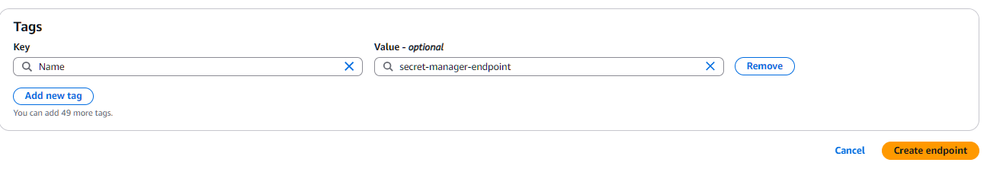

KMS enpoints

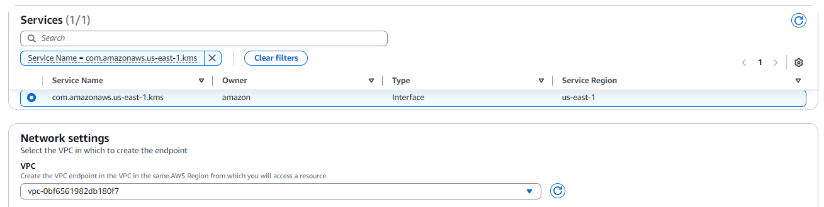

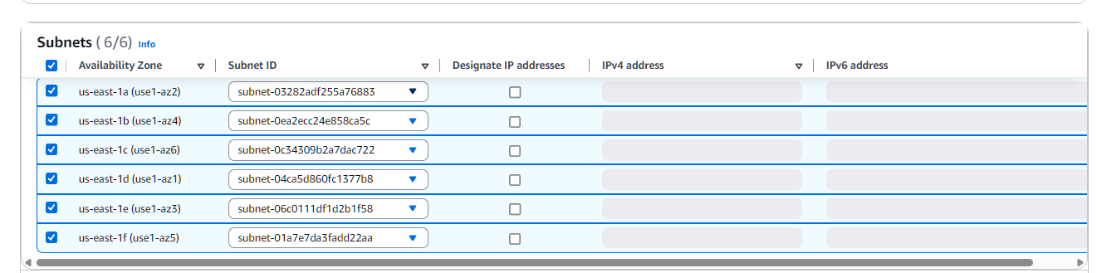



Sts endpoint

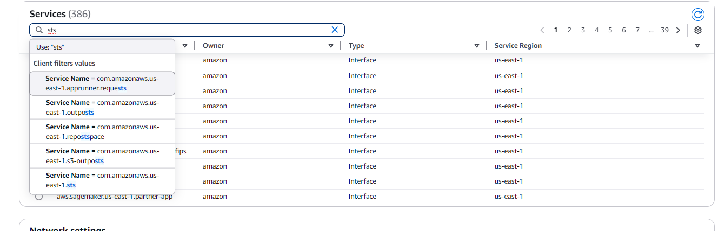

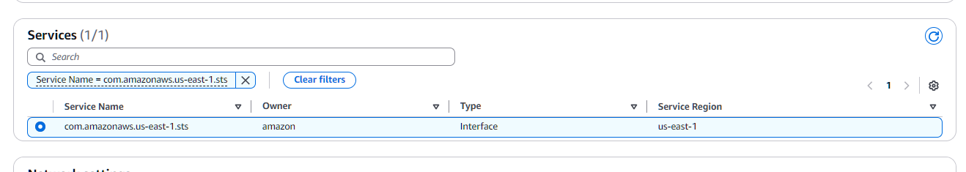







Step3: Check security group

Go to redshift security group

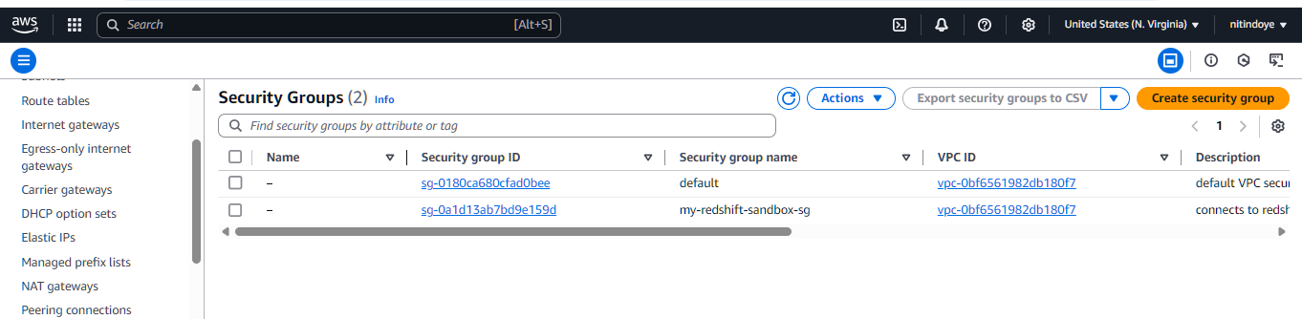

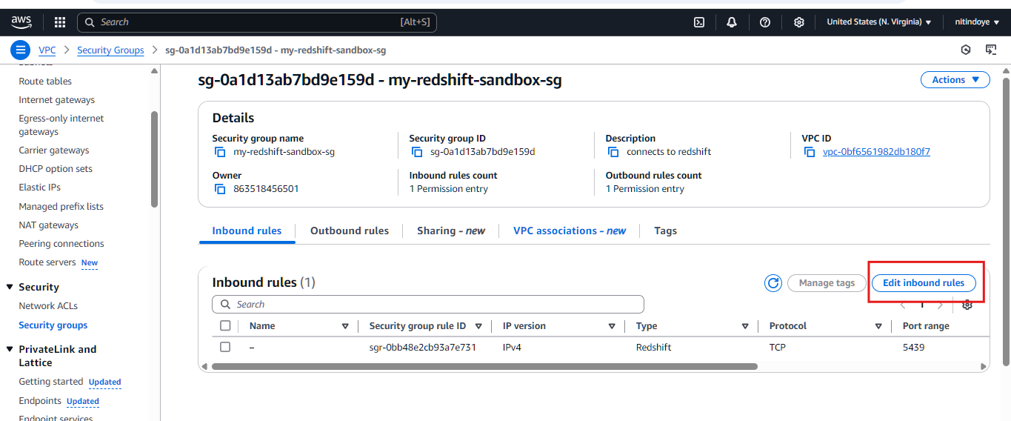

Click on edit inbound rule

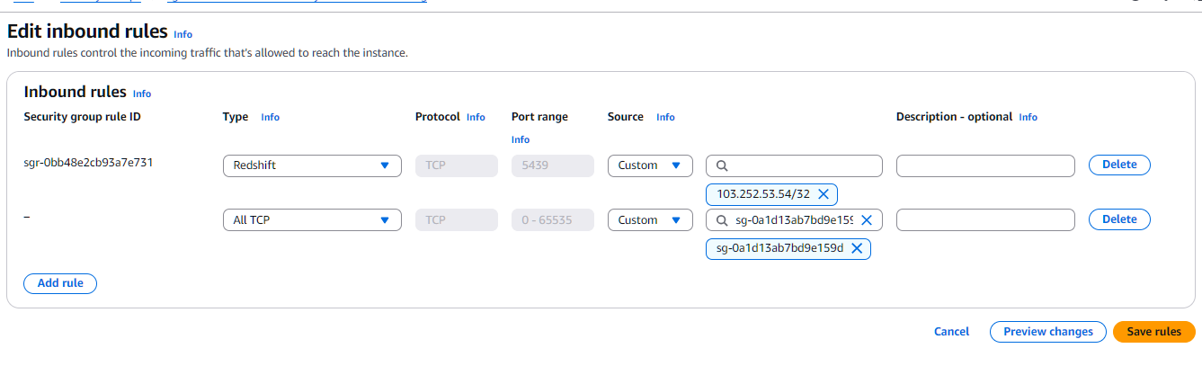

Add inbound rule like type All TCP custom copy security group id and save rule

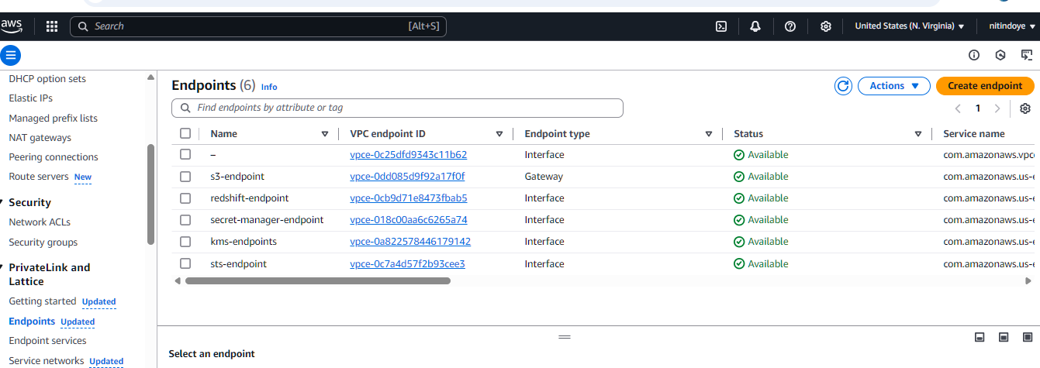

Now go to the glue and create connection

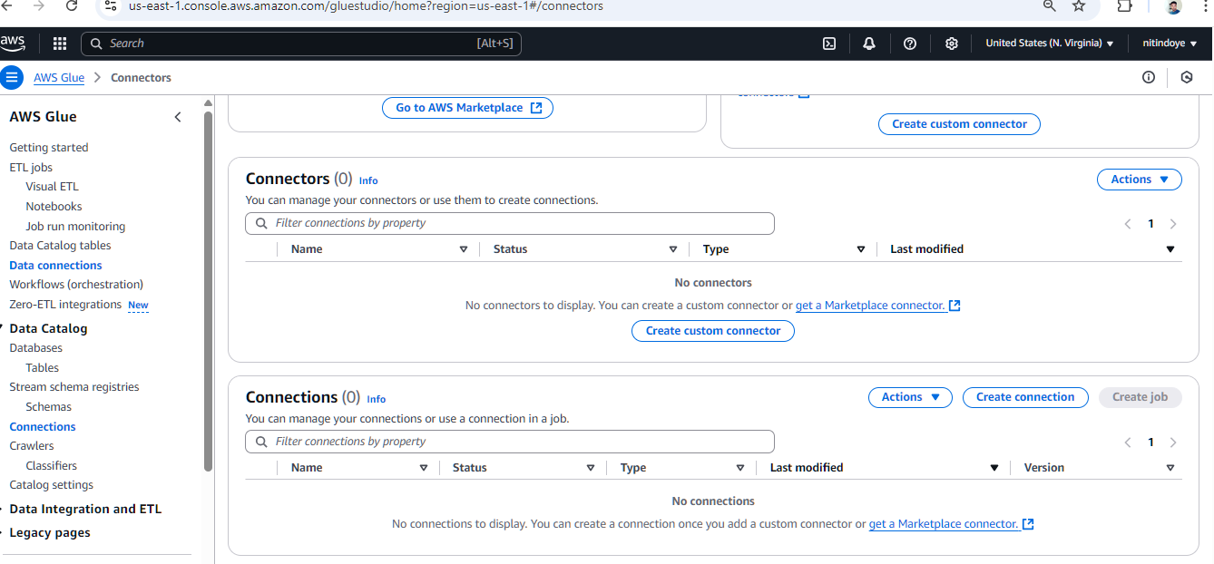

Click on create connection

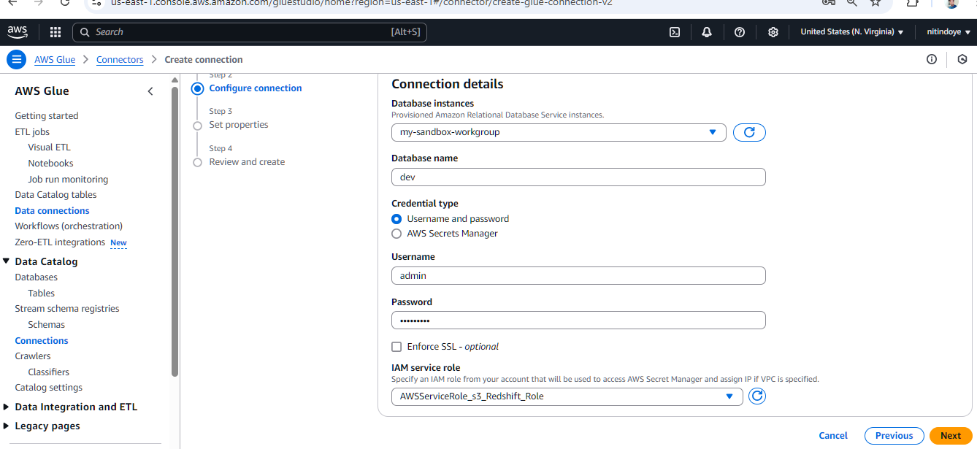

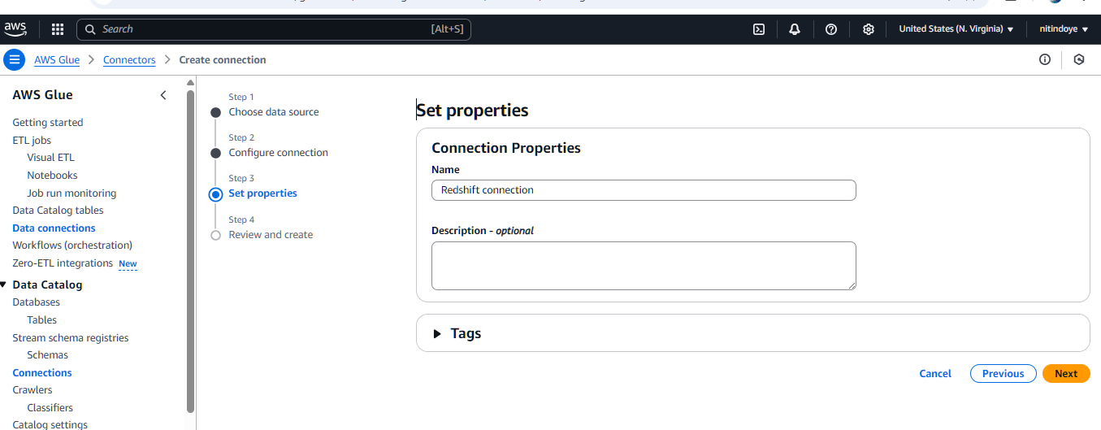

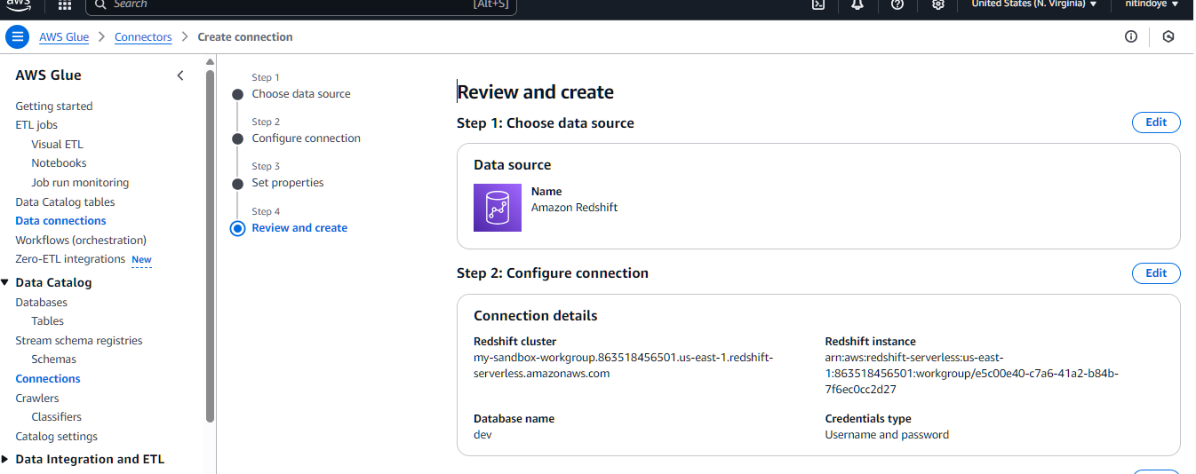

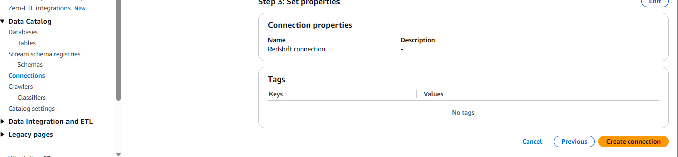

Click on create connection

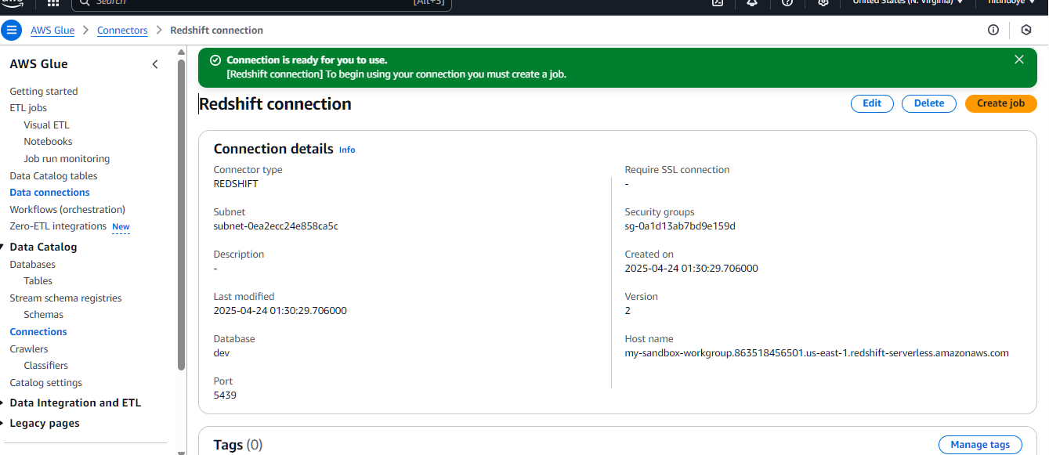

Now Test the connection

